**COM3032 Computer Networks Midterm Exam 28 April 2023**

**Name & Surname: Ömer Faruk Uysal**

**Student ID: 19290337**

**1.** Please fill in the blanks using the appropriate ones from the terms given below (5 pts each, 40 pts total).

*transmission delay, nodal delay, network core, access networks, propagation delay, network edges, processing delay, queuing delay*

While network edges consist of edge systems, access networks include wired, wireless communication links. On the other side, the mesh of packet switches and links that interconnects the Internet’s end systems is called the network core.

As a packet travels from one node to the subsequent node along the network, the packet suffers from several types of delays. Processing delay is the time required to examine the packet’s header and determine where to direct the packet. Queuing delay is the time that a packet waits to be transmitted into the link. The amount of time required to push all of the packet’s bits into the link is called transmission delay and the time required to go from the beginning of the link to the receiving node is the propagation delay. Together, these delays accumulate to give a total nodal delay.

**2.** Please write the answers for the definitions given below (5 pts each, 25 pts total).

a) the protocol to automate the IP configuration (IP address, subnet mask, default gateway, and DNS information): Dynamic Host Configuration Protocol (DHCP)

b) a software interface through which a process sends messages into, and receives messages from: socket

c) type of the HTTP connection in which all of the requests and their corresponding responses are sent over the same TCP connection:Persistent HTTP connection

d) the layer that is responsible for process to process delivery in a general network model: Transport layer

e) the layer that provides the services to user: Application Layer

**3.** Please explain shortly how a UDP connection is established between the sending and receiving hosts (10 pts).

Since UDP is connectionless protocol, there is no need for handshaking before establishing the UDP connection. The Sender host simply creates a datagram to sent with the port numbers of source and destination, and IP addresses of source and destination. Meanwhile the receiver listens the specified port for coming messages. When datagrams is received by destination host, data is extracted and processed.

**4.** Please complete the following link state routing table using Dijkstra's algorithm by computing the shortest path from node A to all of the nodes (25 pts).

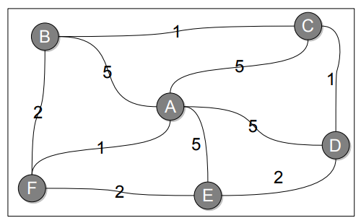

|  |  |  |  |  |  |  |
| --- | --- | --- | --- | --- | --- | --- |
| **Step** | **N’** | **D(B),p(B)** | **D(C),p(C)** | **D(D),p(D)** | **D(E),p(E)** | **D(F),p(F)** |
| **0** | A | 5,A | 5,A | 5,A | 5,A | 1,A |
| **1** | AF | 3,F | 5,A | 5,A | 3,F | … |
| **2** | AFB | … | 4,B | 5,A | 3,F | … |
| **3** | AFBE | … | 4,B | 5,A | … | … |
| **4** | AFBEC | … | … | 5,A | … | … |

When there is a tie between the current estimated costs (I mean D(x) values), we can break the tie arbitrary. Also when the previous least cost and the current calculated cost via any node are equal, you can chose any of these two paths. For example, during the filling table, at step 4, previous cost of the minimum path from A to D is 5 and also the new calculated value for the cost is 5 via the nodes A-F-B-C-D. So I kept it as same